**CMPS 115 Sprint 3 Plan**

**Goal**

After the third sprint, authors will receive various quality of life features such as the ability to edit existing comics and being able to organize their comics in different ways.

**Task Listing**

**User Story 1** - As an author, I would like to be able to organize my comic in different ways so

that users can read my content more easily and it is easier for me to manage my

comics.

**Acceptance Criteria**: An author is able to explicitly create chapters and volumes from the

comic management UI as well as designate which chapter or volume a comic should

belong to. The user then sees the pages as belonging to the said chapters or volumes and

can skip to particular chapters.

* Create the UI for adding chapters and volumes (4 hrs)
* Create the UI for organizing pages into chapters and volumes (3 hrs)
* Create the UI for viewing chapters and volumes (3 hrs)

*Total Time - 10 hrs*

**User Story 2** - As an author, I would like to schedule pages/chapters to release automatically

so that I can manage my comics more easily.

**Acceptance Criteria**: An author can set a particular release schedule for uploaded comics (eg

mondays and fridays). Pages they add are then set as unreleased, and are marked as

released on the scheduled days. Unreleased pages should not be visible to users.

* Add a release schedule to the comic schema (2 hours)
* Give authors the ability to set their release schedule (4 hours)
* Build a system to automatically mark comics as published when the assigned time

arrives (4 hours)

*Total Time - 10 hrs*

**User Story 3** - As a reader, I want my images to be scaled to a resolution that is appropriate

for my network connection so that they download quickly.

**Acceptance Criteria**: The server shall downscale comic page images into smaller sizes that use

less bandwidth to serve. These smaller images will have systematically different names.

* Define the expected aspect ratio for thumbnail images (4 hours)
* Make comic pages scale down to lower resolutions without throwing away the original high resolution images (5 hours)
* Serve scaled down versions of pages (1 hour)

*Total Time - 10 hrs*

**User Story 4** - As an author, I would like to be able to manipulate my existing comics so that I

can manage my comics more easily.

**Acceptance Criteria**: There should be a view by which an author can make changes to a

previously uploaded comic. This includes being able to change the description, thumbnail

and title, but not the url.

* Make a backend route to update an existing comic (4 hours)
* Make the UI that allows a user to change their comic information ( 4 hours)

*Total Time - 8 hrs*

**User Story 5** - As a user, I would like to be able to create a public profile where my biography

and comics are publicly displayed so that other users can understand who I am.

**Acceptance Criteria**: User profiles should be disabled by default. If a user wants to enable

their profile, they can do so through a view. Once enabled, the profile should be read

only to other users. Profiles may contain the user’s biography. Profiles should also be

automatically populated with a list of comics that the user has authored. Finally, those

comics should have a link back to the profile.

* Create a UI to create a user profile (4 hrs)
* Create a route to edit a user profile (4 hrs)
* Create a UI to view other people’s profiles, which contains the user’s name, biography, and comics (4 hrs)
* Add a link that takes a reader from a comic to the owner’s user profile (2 hrs)

*Total time - 14 hrs*

**Team Roles**

Will: Product Owner, Full-stack Dev

Myron: Backend Dev

Sammy: Backend Dev

James: Scrum Master, Frontend Dev

Mehtab: Backend Dev

Alan: Full-stack Dev

**Initial Task Assignment**

Will: User story 3 - Define the expected aspect ratio for thumbnail images (4 hours)

Myron: User story 4 - Make the UI that allows a user to change their comic information (4 hours)

Sammy: User story 2 - Add a release schedule to the comic schema (2 hours)

James: User story 5 - Create a UI to create a user profile (4 hrs)

Mehtab: User story 4 - Make a backend route to update an existing comic (4 hours)

Alan: User story 1 - create ui for creating chapters and volumes (4hrs)

**Initial Burnup Chart**

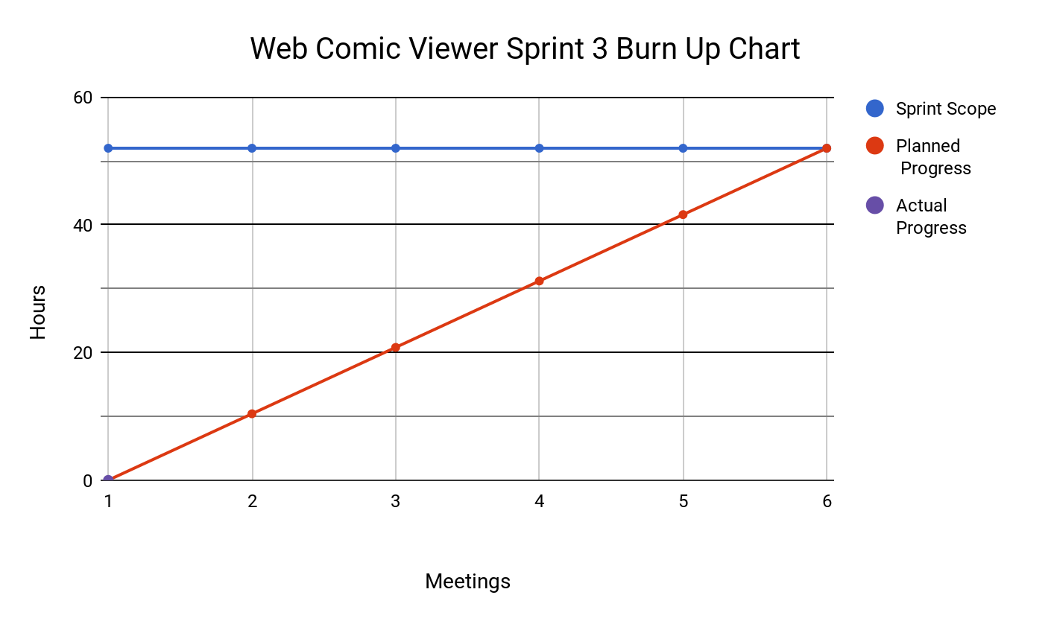

**Scrum Times**

Monday: 4:00-4:15

Tuesday: 4:10-4:25 - TA meeting

Thursday: 3:30-3:45